**Super Store Project Analysis**

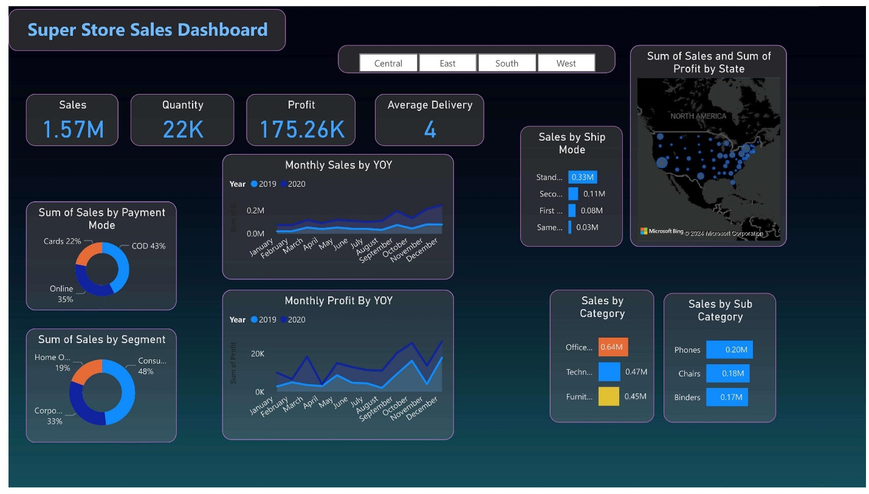

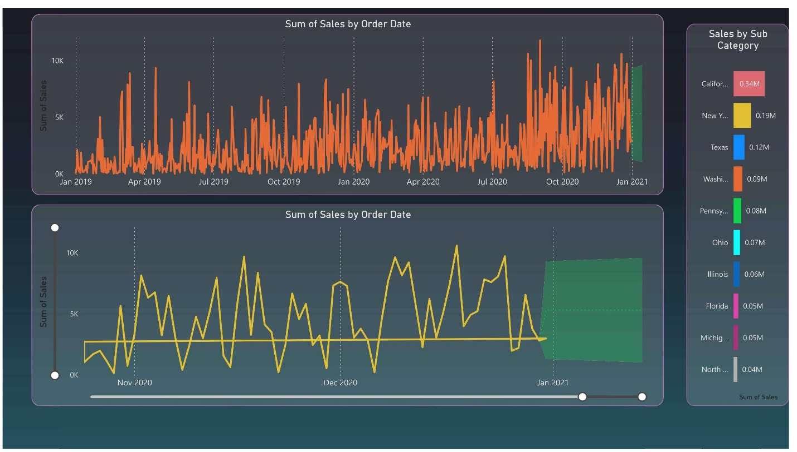

Sure! I'll help you extract key insights from the Super Store Sales Dashboard for your data analyst interview preparation. Let's analyze the visualized data step-by-step:

Super Store Sales Dashboard Insights

General Overview

1. Sales, Quantity, Profit, and Average Delivery:
   * Sales: $1.57M
   * Quantity: 22K units
   * Profit: $175.26K
   * Average Delivery: 4 days

These metrics give a quick snapshot of overall performance, showing the total revenue, units sold, profit margin, and average delivery time.

Sales by Payment Mode

* Cards: 22%
* COD (Cash on Delivery): 43%
* Online: 35%

Insight: COD is the most popular payment mode, followed by Online and Cards. This indicates that customers prefer the security of paying upon delivery.

Sales by Segment

* Home Office: 19%
* Consumer: 48%
* Corporate: 33%

Insight: The Consumer segment dominates the sales, suggesting that individual consumers are the primary target audience, while Corporate and Home Office segments also contribute significantly.

Monthly Sales and Profit (Year-over-Year)

* Monthly Sales YOY: Shows a steady increase in sales from 2019 to 2020.
* Monthly Profit YOY: Profits also exhibit an upward trend, with noticeable peaks and valleys.

Insight: Both sales and profits are growing year-over-year, indicating healthy business growth. Seasonal trends might affect these metrics, with certain months performing better than others.

Sales by Ship Mode

* Standard: 0.33M
* Second Class: 0.11M
* First Class: 0.08M
* Same Day: 0.03M

Insight: Standard shipping is the most preferred mode, significantly outpacing other options. This could be due to cost considerations or delivery reliability.

Sales and Profit by State

* Insight: Certain states (e.g., California) show higher sales and profit volumes. This could be due to population density, economic conditions, or marketing efforts.

Sales by Category and Sub-Category

* Categories:
  + Office Supplies: $0.64M
  + Technology: $0.47M
  + Furniture: $0.45M
* Sub-Categories:
  + Phones: $0.20M
  + Chairs: $0.18M
  + Binders: $0.17M

Insight: Office Supplies lead in sales, followed by Technology and Furniture. Within these categories, specific sub-categories like Phones and Chairs drive significant sales.

Sales by Order Date

* Upper Chart: Consistent daily sales fluctuations over two years, with peaks around major shopping periods.
* Lower Chart: Detailed sales trend towards the end of the analyzed period, showing high variability.

Insight: Sales have a clear seasonal pattern, with spikes during holiday seasons or promotional events. This suggests that marketing and sales efforts should focus on these peak periods.

Conclusion

* Overall Performance: The store demonstrates robust sales and profit growth, with clear preferences in payment modes and shipping options.
* Customer Segmentation: The Consumer segment is the primary target, with significant contributions from Corporate and Home Office segments.
* Geographic Insights: Certain states like California contribute more to sales and profits, indicating potential for targeted marketing.
* Product Insights: Office Supplies dominate the category sales, and specific sub-categories like Phones and Chairs are key drivers.

These insights can be leveraged to make data-driven decisions in marketing, inventory management, and customer service to further enhance business performance. When discussing this project in an interview, highlight your ability to extract actionable insights from data visualizations and how these can drive business strategy.

Top of Form

Bottom of Form